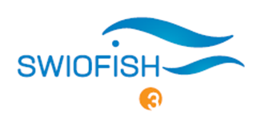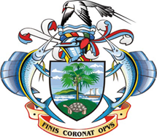 **Towards Environmental and Social Safeguards** 

**Step 2**

If YES, what can you do to **avoid**, **minimize** or **mitigate** these risks?



Here are some examples of mitigation measures you can adopt

**Environment**

1. Follow nature reserves' protocol and to always be with field experts
2. Deployment of VMS trackers which provides fishing location for each trip
3. Ensure to have waste disposal system

Training in procedures of handling and disposal of potentially hazardous materials

1. Develop and implement a protocol for tagging of target species

Train staff in tagging of target species

1. Develop a snorkelling and diving code of conduct

Conduct snorkelling/dive briefings prior to every snorkelling/dive

Develop and follow coral sampling field work protocol

**Health and safety**

1. Training in health and safety
2. Training in first aid
3. Develop an emergency assistance & evacuation plan

Familiarize fishers in SOS alerts and maritime rescue channels

1. Follow lab safety protocol & use of personal protective equipment

**Social**

1. Conduct consultative meetings with project affected persons

**Step 3**

Do you have the necessary **skills** and **equipment** to APPLY and to MONITOR the implementation of the mitigation measures?

IF NO, include in your **itemized budget** the COST for each mitigation measure. For example:

* Develop protocol to undertake sampling/field work
* Purchase of health insurance
* Training in first aid
* Purchase of personal protective equipment (gloves, boots, hard hats, etc.)
* Develop a stakeholders’ engagement plan

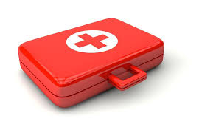 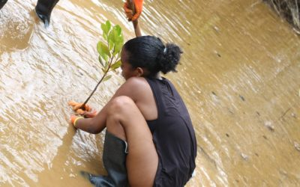



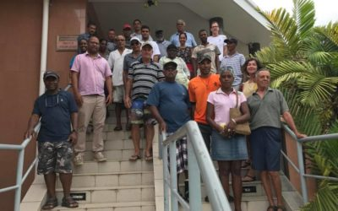

**Step 1**

Do your project activities have potential **Environmental and Social risks**?

Here are some examples:

**Environmental risks**

1. Disturbance/damage to flora and fauna
2. Illegal fishing of protected species and/or in protected/sensitive areas
3. Pollution (land, water, air, noise)
4. Target species mortality
5. Trampling on coral reefs

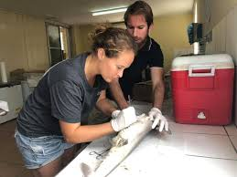 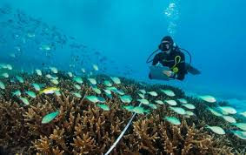

**Health and safety risks**

Injuries and accident

1. Cuts/bruises
2. Seasickness
3. Drowning
4. Contamination

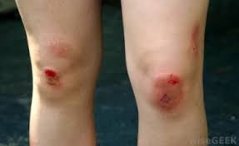 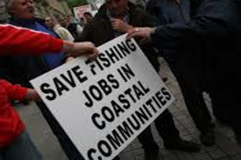 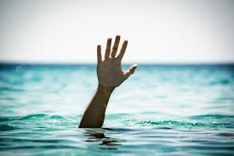

**Social risks**

1. Alteration of livelihood

*Relocation or loss of shelter*

*Loss of assets or access to assets*

*Loss of income sources or means of livelihood*

*The involuntary restriction of access to legally designated parks and protected areas*