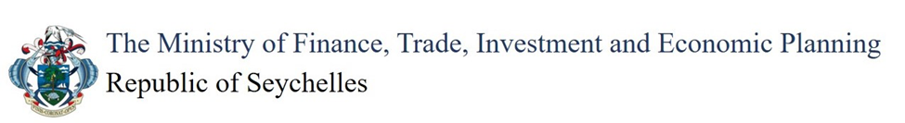

THIRD SOUTH WEST INDIAN OCEAN FISHERIES GOVERNANCE AND SHARED GROWTH PROJECT (SWIOFish3)

Subproject Name

Subproject Location

Environmental and Social Administrative Eligibility Report for SWIOFish3 Project

Month Year
Sub-project Summary

Proponent:………………………………………………………………………………………

Sub-Project Name: ……………………………………………………………………………

Sub-Project Location: ……………………………………………………………………………….

Estimated Sub-Project Cost: ………………………………………………………………………...

Sub-Project Objectives: ……………………………………………………………………………..

Brief Description of Proposed Sub-Project: ……………………………………………………….

Eligibility check:

 | Yes | No
Does the subproject fall under the indicative list of eligible activities to be funded under the BIF?

Eligibility check against the exclusion list

Any sub-project meeting any of the below listed criteria will be ineligible for funding under the SWIOFish3 Project.

Sub-projects in Exclusion List | Yes | No
Sub-projects located within or adjacent to a protected or an ecologically sensitive area, as defined in Schedule 2 of the Environment Protection (Impact Assessment) Regulations
Sub-projects that involve the significant conversion or degradation of critical natural habitats such as sensitive ecosystems. converting mangrove forests to aquaculture use or other land uses, or other unsustainable cutting of mangrove forests
The introduction of any new exotic marine species (note: this provision does not apply to any native and/or naturalized species, or any micro-algae that is imported as live feed)
Activities that could dangerously lead to the exposure of sensitive/critical/vulnerable habitats unsustainable or illegal fishing activities (e.g., illegally-sized nets, spear fishing, use of dynamite, etc.)
Construction of permanent buildings within the wetlands
Construction of walls in or around wetlands which will interrupt water flow
The tidying of wetlands or mangroves by the removal of dead wood that serves as habitat for multiple fish species
Extraction of raw material from protected areas
Filling of wetlands within protected areas and outside in strategic landscapes.
Sub-projects which cause significant socioeconomic impacts involving permanent involuntary resettlement resulting in relocation of people or displacement of houses or building structures; or loss, denial or restriction of access to land, crops and other economic assets; or significant loss of sources of income or means of subsistence)
Sub-project which physically block or restrict fishers’ access to the water (e.g., structures with walls or other shoreline obstructions or barriers that physically prevent fishers from accessing or launching their boats using customary or longstanding paths, roads or other rights of way)

Form prepared by:

Signature: Date: ____________

Name (print): Job Title:

Form approved by:

Signature: ________________________________ Date: _____________________________

Name (print): ___________________________ Job Title: ___________________________

