Using the Online Awards Platform
SeyCCAT is trialing an online awards platform for ease of the application process. The entire application process should be completed through an online portal where you will have the ability to provide additional evidence (links to websites, testimonials, etc.)
Steps
1) Click on the following link to enter the application website: https://seyccat.awardsplatform.com
2) Register with the following details:
- First name
- Last name
- Email
- Mobile
- Password
- Confirm Password ** Save your password**
- Agree to the terms and conditions
- Agree to receiving communications from SeyCCAT.
3) You can return to your application and login, use the following details:
- Username: (your email address)
- Unique Password: as set above.
4) There are three sections which require documents to be uploaded
a. Schedule – The concept note requests that you include a timeline or a gantt chart for your project. A Microsoft word document can be attached here.
b. Project Budget – This is the template that must be used: Project Budget
c. Itemized budget – This is the template that must be used: Itemized budget
5) ATTACHMENTS: You can attach other documents such as CV and support letters as indicated in the online application form, including on the “Attachment” Tab.
In the event that you face difficulties with uploading documents under the “Attachment” Tab, please contact the SeyCCAT secretariat on info@seyccat.org indicating what difficulties you are having and obtain advice.
SUBMISSION
6) For you to submit the form, you have to click on the “Criteria” Tab and confirm that you are eligible for the Blue Grants Fund.
7) Once you have submitted the form, you can amend it until the close of the application window.
8) You can save your application and come back to it later, but ensure that you complete it before the deadline on 15th May 2020 at 5 PM as the application window will automatically close and won’t accept any applications.

Once you submit, you should receive a confirmation email in your inbox with the email address linked to the application.

If you have any difficulty accessing or using the online application form, please complete the application on a Microsoft Word document offline (attached), then proceed to either venues to input your application into the online application platform:

- The Guy Morel Institute (former S.I.M) can offer a computer room to complete the application form.
- SeyCCAT Secretariat (Room 109, Oceangate House) can offer you a space to enter the offline application into the online application form. If you require the use of a laptop, please email us on info@seyccat.org with a minimum of 2 days in advance.

DOWNLOAD YOUR FILE AS A PDF FOR RECORD-KEEPING

In view that this is a pilot of the use of the system that is highly ranked by its international users, to avoid any unexpected systems failure please ensure you download a copy of your application on PDF and save a copy of your document.

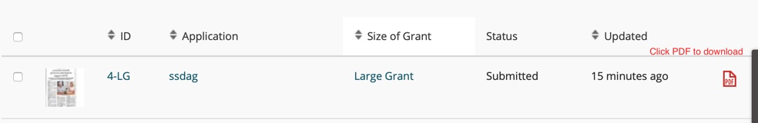

If for any reason, you cannot submit the application as a result of problems with your internet, you must call the SeyCCAT Secretariat in advance to inform them and be guided on next steps. To avoid such situations, we would strongly recommend that you do not send your application at the last minute.

