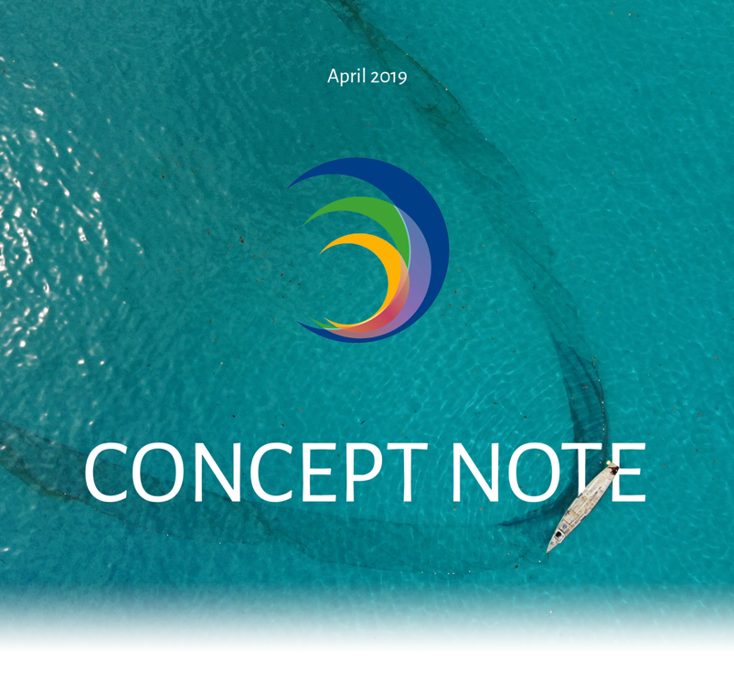

Project Title
SeyCCat Route to Market Survey. By Active Group: Explore the route to market for seafood from local fishermen

Lead Organization/Individual
Shahiid Melanie c/o Active Group

Date of Submission
05/15/2019

INSTRUCTIONS

INSTRUCTIONS

Read the following before designing your concept…

All proposals submitted to the fund must have as their main purpose the conservation and/or management of marine and coastal biodiversity and/or ecosystem-based adaptation to climate change in the Seychelles.

Refer to the Call for Proposals to see the priorities for funding in the current round of SeyCCAT grants. Do not submit a proposal that falls outside of these identified priorities.

Do not include activities or costs that are defined as ineligible by SeyCCAT.

Proposals must be compliant with Environmental and Social Safeguards applied by SeyCCAT. Please pay particular attention to the Exclusions List.

Refer to the SeyCCAT website for information on the above: www.seyccat.org

In the event of specific questions, contact the SeyCCAT Secretariat at:

SEYCHELLES’ CONSERVATION AND CLIMATE ADAPTATION TRUST
Oceangate House, Room 109, Flamboyant Avenue, Victoria, Mahe, Seychelles.
www.seyccat.org // info@seyccat.org // +248 432 5806

In preparing your concept…

- Be clear and concise.

- Follow the guidelines and instructions (major points) described below.

- The concept should be provided in Font Times New Roman size 11 characters, single spacing.

- The concept should not exceed five (5) pages in length (excluding budget and Annex).

BACKGROUND INFORMATION

BACKGROUND INFORMATION

BACKGROUND INFORMATION

BACKGROUND INFORMATION

BACKGROUND INFORMATION

BACKGROUND INFORMATION

BACKGROUND INFORMATION

BACKGROUND INFORMATION

Small-medium grant
Large grant
(tick)

Project Title
Explore the route to market for seafood from local fishermen

SeyCCAT Strategic Objective – as listed in the Request for Proposals
Trial and nurture business models to secure the sustainable development of Seychelles’ blue economy.

Name, contact details and status of lead applicant organization / individual
Organization/institution or individual, contact details (if an organization/institution, give the contact person).
Include date of formation; if an individual, provide evidence of your citizenship / NIN.
Shahiid Melanie

996-1471-1-1-82

+248 2541055

ACTIVE GROUP

Account Number : 00000654687
IBAN Number : SC19MCBL06010000000000654687SCR
Swift Code : MCBLSCSC
Bank Address :
The Mauritius Commercial Bank (Seychelles) Ltd.
P.O.Box 122
Manglier Street
Victoria, Mahe
Seychelles

Partner organizations (include country if not based in Seychelles)
Seychelles Fisheries Authority

Enterprise Seychelles Agency

Project Location
Ile Perseverance

Duration – start and end dates
In months: small-medium grants not to exceed 12 months; large grants not to exceed 24 months
8 Months From October 2019 until May 2020

Total Budget Requested
Note the upper limit as per the guidelines.
98,300 SR

Indicative co-financing
Co-financing is not needed for small-medium grants (but may be indicated) and is encouraged for large grants. Co-financing provides an indication of broader support for the project.
Please provide details of the source of co-finance and the amount of co-finance.

There will be no co-financing, as the grant will be fully financed by SeyCCAT.

PROJECT DESCRIPTION

PROJECT DESCRIPTION

PROJECT DESCRIPTION

PROJECT DESCRIPTION

PROJECT DESCRIPTION

PROJECT DESCRIPTION

PROJECT DESCRIPTION

PROJECT DESCRIPTION

Abstract (500 words max)
Briefly describe the proposed project. Clearly identify the threats to be addressed and the proposed solution, project beneficiaries, etc.
If your project overlaps or duplicates activities of a previous or on-going project funded by SeyCCAT or another donor be sure to indicate here why your project is different and /or necessary. Failure to do so will mean automatic rejection of the proposal.
If the project is part of a coordinated proposal to several donors simultaneously this must be stated.
• Liaise with local stakeholders so they get paid as soon as they reach the shores
• Getting a network setup between the clients and suppliers within the fisheries industry.
• Establishing a direct delivery route to the market for the tourism industry, local establishments and the residents of Seychelles.
• Create a database of residents GPS co-ordinates for delivery.
• Create a database of the local fishermen.
• Establish an online ordering platform for clients.
• Gain a thorough knowledge of the sales frequency.
• Find out the challenges of the local fishermen within their routes to market.
• Establish a Seafood Discount Club for customers that will build customer loyalty and promote the local fishing stakeholders.
• Establish an online presence via social media groups
• Establish a website for easy ordering with an admin for our contacts database
• Establish a mobile app for easy ordering and an admin for recording locations

Outcome and impacts
What is the intended outcome and likely impacts of the project (what will be achieved at project end)?
By liaising with local stakeholders and getting a network setup between the clients and suppliers within the fisheries industry, we can establish a direct delivery route to the market for the tourism industry, local establishments and the residents of Seychelles.

This will in turn, provide us with enough data to create a database of residents GPS co-ordinates for delivery, the local fishermen's place of trade and contact information, establish an online ordering platform for clients, whereby we can gain a valuable network of residents within the tourism and other private and government establishments, take-aways and restaurants.

By gaining a thorough knowledge of the sales frequency, we can work on a marketing and sales plan to address the challenges that may be faced for quicker inventory turn around.

Objective(s)
State the objective/s of the project (what is the problem or issue that will be addressed) and ensure your objectives are SMART – Specific, Measurable, Achievable, Realistic and Time-bound.
The SeyCCat Route to Market Survey conducted by Active Group is a project that points towards the fish industry more specifically fish consumption, sustainability and the route to market. The Project will entail the collection of data, which is our main objective.By meeting up with the selected participants it will help us get a chance to discuss the fish consumption and its sustainability and their willingness to buy good food.

The gathering of data will also aim to identify wastage in the route to market, and help curb over fishing, tackling the sustainability of this particular sector.
We will aim to get an understanding of the places where the types of fishes are bought, methods that the anglers use, if they have an understanding of overfishing, if they practice sustainable fishing methods and hygienic practices before retailing and gauge their interest in having better ways of getting their catch bought fresh, directly after landing onshore.

The questionnaire will be divided in two category one for the anglers and one for the consumer. This will help gather data of consumption and typical quantities eaten per eating occasion. The questionnaire will be open-ended with a strong focus on pelagic fish, especially the overfishing of tuna.
Example of Pelagic Fish:
Sailfish Istiophorus platypterus Dyab lavwal
Blue marlin Makaria mazara Espadon ble
Black marlin Makaria indica Espadon nwar
Swordfish Xiphias gladius Espadon
Yellowfin tuna Thunnus albacares Ton zonn
Dogtooth tuna Gymnosarda unicolor Ton ledan
Skip jack Katsuwonus pelamis Ton raye
Bonito Euthynnus affinis Bonit
Wahoo Acanthocybium solandri Kin fis
Dorado Coryphaena hippurus Dorad
Great barracuda Sphyrnea barracuda Tazard
Pickhandle barracuda Sphyranea jello Bekin
Rainbow runner Elagatis bipinnulata Galate
Yellowspotted trevally Carangiodes fulvoguttatus Karang plat
Bludger Carangoides gymnosthetus Karang balo
Giant trevally Caranx ignobilis Karang ledan
Bigeye trevally Caranx sexfasciatus Karang ledan
Bluefin trevally Carnac melampygus Karang
There will also be the creation of an app referred as Goute. Which will help us gather data on an online basis thus benefit the public by means of association we will build with certain fish outlets such as Oceana fisheries and even local anglers that might collaborate on fish based recipes. The next step is to add a recipe feature to the goute app as a means engagement from the public side where it will create traffic on both the website and the app. The goal of this feature is to save users money while at the same time reducing food wastage and getting its users eating healthier. It is an easy and straightforward feature that anyone can use and enjoy.

Outputs
What will be delivered (physical items, materials or infrastructure, training or skills development, etc.)?
- Database of clients locations for delivery.
- Database of local Fishermen
- Database on fish consumption
- A smooth transition to bulk orders for the fishermen
- Wholesale fish website and delivery app
- Thorough knowledge of the route to market

Activities
Briefly list the activities to be undertaken to implement the project. Do they build upon any existing projects?
- Interviews with the residents will be conducted
- Disccussion with the fishermen will be held
- Gathering of data
- Liasing with stakeholder for support
- Build the app goute as a means of engagement to gain traffic.
Schedule
Briefly indicate the schedule or phases of the project. Insert a timeline / Gantt chart to show the sequencing of project activities.
The first 8 months will be purely base on the gathering of data [From October 2019 until May 2020] before any implementation is done.After the fisrt phase is done we will begin our transaction of buying,storing and transporting the product to clients or residents that coorporated with us during the research phase.

Sustainability and replication
Indicate how the proposed activities are sustainable and may be scaled up or replicated. This can include an indication of follow-up activities, strategies, ownership, etc.
Also indicate what might go wrong / what are the possible obstacles or challenges to your proposed project?
The proposed activities needs the coorporation of all involved parties,for it to be a success.Challenges would most likely be in the uncontrolled circumstances such as the residence not being at home or their uninterest to participate,the volunteers lack of experiences,poor communication thus the delay of any needed approval from the stakeholders.

Please also submit a separate document that provides a summary of your project teams’ experience. It should include an annotated list of similar projects implemented and CV’s for the main project team members.
The application must not exceed five (5) pages, not including the budget, checklist and Annex.

CONCEPT NOTE CHECKLIST FOR SUBMISSION

ACTION | COMPLETE
Have you read the SeyCCAT Application Guidelines?
Have you read the environmental and social safeguards policy?
Have you referred to the glossary for explanations of different terms used in the proposal application form?
Have you used the correct Template for Concept Note Applications?
Have you checked the deadline time and date for the submission of the project?
Have you indicated the correct SeyCCAT strategic objective for this call?
Have you included CV’s for all the key project personnel?
Have you provided actual start and end dates for your project (and checked they synchronize with when SeyCCAT would make grant monies available)?
Have you checked the Guidelines on Generic Impacts and Risks of Activities to assess if an Environmental Impact Assessment needs to be carried out or supplemental environmental safeguards instruments prepared?
Have you provided your budget and used the correct template provided for concept notes?
Have you checked that your budget is complete, correctly adds up and that you have included the correct final total on the top page of the application?
If you are supported by co-finance - have you included the value of, and supporting organization for the co-finance, and indicated if it is cash or in kind?
Have you checked the SeyCCAT website immediately prior to submission to ensure there are no late updates?

Once you have answered Yes to the questions above, please submit the application in Word format, not later than 5PM (Seychelles time) on to the due date advertised in the request for proposals to:
info@seyccat.org using the title of the project (or first few words) as the subject of your email. You do not need to send a hard copy. Please note, you can submit any time before the due date, you do not have to submit on that date itself.
If you are e-mailing supporting documentation separately please include in the subject line an indication of the number of e-mails you are sending (e.g. whether the e-mail is 1 of 2, 2 of 3 etc). You are not required to send a hard copy.

