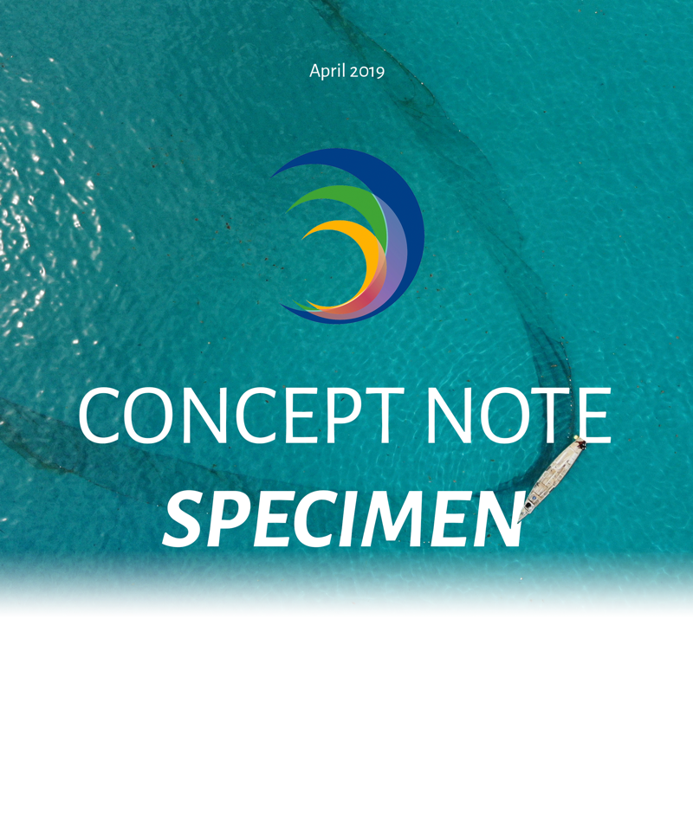

Project Title
Marine Biodiversity Baseline assessment around Frégate Island, the eastern most Seychelles ‘Inner’ granitic island.

Lead Organization/Individual
Green Islands Foundation, Belair Road, Victoria, Mahé

Date of Submission
01/01/2019

PLEASE NOTE
This Specimen Concept Note has been provided as an exemplary Concept Note submission. The contents of this Concept Note should be used solely to provide direction on the contents of 2019 applications and should not be distributed or altered without the prior written consent of SeyCCAT. Confidential information in this document, including financial information, has been excluded or altered.

INSTRUCTIONS

INSTRUCTIONS

Read the following before designing your concept…

All proposals submitted to the fund must have as their main purpose the conservation and/or management of marine and coastal biodiversity and/or ecosystem-based adaptation to climate change in the Seychelles.

Refer to the Call for Proposals to see the priorities for funding in the current round of SeyCCAT grants. Do not submit a proposal that falls outside of these identified priorities.

Do not include activities or costs that are defined as ineligible by SeyCCAT.

Proposals must be compliant with Environmental and Social Safeguards applied by SeyCCAT. Please pay particular attention to the Exclusions List.

Refer to the SeyCCAT website for information on the above: www.seyccat.org

In the event of specific questions, contact the SeyCCAT Secretariat at:

SEYCHELLES’ CONSERVATION AND CLIMATE ADAPTATION TRUST
Oceangate House, Room 109, Flamboyant Avenue, Victoria, Mahe, Seychelles.
www.seyccat.org // info@seyccat.org // +248 432 5806

In preparing your concept…

- Be clear and concise.

- Follow the guidelines and instructions (major points) described below.

- The concept should be provided in Font Times New Roman size 11 characters, single spacing.

- The concept should not exceed five (5) pages in length (excluding budget and Annex).

BACKGROUND INFORMATION

BACKGROUND INFORMATION

BACKGROUND INFORMATION

BACKGROUND INFORMATION

BACKGROUND INFORMATION

BACKGROUND INFORMATION

BACKGROUND INFORMATION

BACKGROUND INFORMATION

Small-medium grant
Large grant
(tick)

Project Title
Marine Biodiversity Baseline assessment around Frégate Island, the eastern most Seychelles ‘Inner’ granitic island.

SeyCCAT Strategic Objective – as listed in the Request for Proposals
Strategic Objective #1
DON’T
- Include more than one Strategic Objective

Name, contact details and status of lead applicant organization/individual
Organization/institution or individual, contact details (if an organization/institution, give the contact person).
Include date of formation; if an individual, provide evidence of your citizenship / NIN.
[CONTACT NAME]
Green Islands Foundation, Belair Road
Victoria, Mahé
Republic of Seychelles
[CONTACT DETAILS]
DO
- Make sure you include contact details that are up to date

Partner organizations (include country if not based in Seychelles)
Frégate Island Private, Seychelles
University of Seychelles/James Michel Blue Economy Research Institute, Seychelles
Coralive.org (Zurich, Switzerland)

Project Location
Frégate Island Private, Seychelles

Duration – start and end dates
In months: small-medium grants not to exceed 12 months; large grants not to exceed 24 month
24 months
Start: 01/01/2019
End: 31/12/2020
DO
- Make sure that the duration does not exceed the maximum duration for your type of project

Total budget requested
Note the upper limit as per the guidelines.
123456 SR
DO
- Make sure that your total budget has been calculated correctly and includes ALL associated costs, including those related to monitoring and evaluation, and any relevant taxes

Indicative co-financing
Co-financing is not needed for small-medium grants (but may be indicated) and is encouraged for large grants. Co-financing provides an indication of broader support for the project.
Please provide details of the source of co-finance and the amount of co-finance.
Blancpain Ocean Commitment have agreed to co-finance up to a third of project costs ($1234) based on receiving a grant award from SeyCCAT. Frégate Island Private will provide services in-kind up to half of the amount of SeyCCAT awarded grant incl. travel expenses and salary of contractual experts. UniSey costs will come from data storage, student supervision, and technical infield assistance.
DO
- Remember that co-financing is not needed for small-medium grants
- Remember that co-financing is encouraged for large grants
- Make sure that the amount of co-finance pledged is accurate and if pledged in another currency, that any transaction/conversion costs are accounted for

PROJECT DESCRIPTION

PROJECT DESCRIPTION

PROJECT DESCRIPTION

PROJECT DESCRIPTION

PROJECT DESCRIPTION

PROJECT DESCRIPTION

PROJECT DESCRIPTION

PROJECT DESCRIPTION

Abstract (500 words max)
Briefly describe the proposed project. Clearly identify the threats to be addressed and the proposed solution, project beneficiaries, etc.
If your project overlaps or duplicates activities of a previous or on-going project funded by SeyCCAT or another donor be sure to indicate here why your project is different and /or necessary. Failure to do so will mean automatic rejection of the proposal.
If the project is part of a coordinated proposal to several donors simultaneously this must be stated.
Frégate Island has a long conservation history for its terrestrial environment and many Seychelles endemic species are found there, including the Frégate tenebrionid beetle which is only found on this one island. It’s also home to 50% of the Seychelles magpie robin population, Seychelles warbler and Seychelles white-eye. Rats were eradicated from the island and currently the island remains rat-free, following strict biosecurity protocols to maintain that status.

Despite great success on land, the marine environment around Frégate Island is poorly understood especially in terms of the distribution of organisms within the fringe coral reef. To advance understanding of the marine life around Frégate Island, we propose a partnership between Frégate Island Private, Green Islands Foundation (GIF), Blue Economy Research Institute (BERI) and Coralive.org to establish a coral reef biodiversity baseline and initiate a long-term marine monitoring programme around the island. The partnership aims to create important local and international collaborations that benefit conservation of marine life around Frégate Island and in the Seychelles by identifying a critical habitat to protect and manage (Project 5, SNBSAP)

Long-term, marine ecological research programmes are needed to improve our understanding of the complex mechanisms that govern coral reef ecosystems. Information generated by a long-term marine programme at Frégate Island will help to distinguish anthropogenic change from natural variation, understand the combined effects of various stresses, predict how different parts of the reef community may be affected by environmental change, and identify activities both within and outside coral reef ecosystems that affect the survival of coral reefs.

This project proposes to collect data for an initial assessment of the coral reef assemblage and associated marine species, and monitor trends over time. The data will be collected through standardized marine monitoring scientific methodologies currently employed by GIF, thus, can be used to compare findings with other granitic islands. The marine monitoring will be augmented with novel spatial monitoring technologies provided by Coralive.org. The research will produce reports about the state of Frégate Island’s coral reef with more specific questions being answered through Environmental Science bachelor student’s final year projects. In addition, public awareness on the threats facing coral reefs and marine conservation will be enhanced using state of the art technologies such as 3D virtual reef mosaics. Ultimately, by compiling all the research outlined in this project, we aim to provide recommendations for decisions to be made on the potential for creating an MPA around Frégate Island.

Outcome and impacts
What is the intended outcome and likely impacts of the project (what will be achieved at project end)?
Through collaborative scientific research, this project aims to improve the knowledge on the state of the marine environment around Frégate Island, with a view to create a marine protected area around the island. This would advance better management of the waters around the island, development of long-term marine monitoring protocols, enhance public awareness, and contributing to the 2020 vision contained in the Seychelles’ Sustainable Development Strategy.
DO:
- Include a single, overarching goal
- Provide indication of benefits. What will change? Who/what will benefit?
- Keep your outcome concise

DON’T:
- Include more than one outcome

Objective(s)
State the objective/s of the project (what is the problem or issue that will be addressed) and ensure your objectives are SMART – Specific, Measurable, Achievable, Realistic and Time-bound.
Objective 1: Conduct initial biodiversity assessment of coral reef species around Frégate Island.

Objective 2: Identify composition and coral reef health through coral cover analysis of Frégate Island coral reef.

Objective 3: Establish long-term marine monitoring program for year-on-year comparison of long-term trends in the structure of reef fish and coral communities.
DO:
- Use action verbs e.g increase, implement, develop
- Include between 3-5 objectives (more/fewer are allowed but not recommended)
- Ensure objectives are SMART (Specific, measurable, achievable, realistic, time-bound)
- Ensure objectives follow a logical order

DON’T:
- Include objectives that do not contribute to the outcome
- Provide an unrealistic amount of objectives

Outputs
What will be delivered (physical items, materials or infrastructure, training or skills development, etc.)?
Objective 1: For each year, an annual report will be produced covering analysis of the survey data collected during the biodiversity assessment and BRUV deployment. Presence and abundance of specific fish indicator species will be analysed using diversity measures using the Simpson index, and Jaccard index for incidence, in addition comparable analysis between survey sites around the island will be conducted, and recommendations made on which habitats would benefit from active management such as creating a no-take zone for sustenance fishing by hotel staff/guests. In year 2, the data will be compared on different levels to see if any change is detected, although we would only expect changes after a few years if management suggestions are implemented. The ultimate deliverables would be to publish the study in a peer reviewed journal and provide open access to the data for data sharing collaborations in Seychelles and internationally.

Objective 2: Coral cover analysis is an essential component for understanding the impacts of climate change as outlined in UN Sustainable Development Goal 14. Our second objective is to understand the impact of coral bleaching due to ocean acidification on Frégate Island’s coral reef. The equipment used produces a 250m wide coral atlas from which we can identify areas of habitat around Frégate Island; coral structure, coral health (bleached/recovering), bedrock, and sand. A key output from this objective will also identify reef areas that would benefit from coral restoration initiatives. In addition, a high resolution 3D model of specific sites will also be created for baseline data to understand how coral reef structures or sites change over time. The 3D model is an interactive environment which will be used by all partners to promote and educate knowledge of coral reefs through our active social media platforms and workshops at local schools on La Digue/Praslin.
Objective 3: Establishing a long-term protocol for marine monitoring around Frégate Island would be designed and implemented by the middle of 2020 based on the information from Objective 1 and 2 reports and projects by students from University of Seychelles. While these project topics have yet to be defined, we intend students to analyze all or parts of the datasets collected in Objectives 1& 2 to answer specific questions regarding coral reef structure and health. In addition, The marine monitoring protocol would aim to delineate coastal areas based on function, such as snorkeling areas, fishing zones, suitable anchor sites that may be used in support of a marine protected area around Frégate Island and Little Frégate.
DO:
- Include specific and direct deliverables of the project
- State conditions necessary to achieve each outcome

Activities
Briefly list the activities to be undertaken to implement the project. Do they build upon any existing projects?
Proposed activities are planned to be combined to achieve project aims. Each objective has associated activities as described below:

Objective 1: Two standardized quantifiable marine survey methods; a) belt transects focusing on indicator coral and fish species; b) deployment Baited Remote Underwater Video Stations (BRUVs) to quantify fish species diversity, richness and mean trophic levels around Frégate Island. The data from these activities will be analyzed and the results will provide the assessment of coral reef fish species around Frégate Island. This data will also be used to achieve Objective 3.

Objective 2: To map and analyze coral cover, a reef mosaicing tool will be deployed. The torpedo shaped unit contains cameras taking pictures every 6 seconds synchronized to a GPS logger on the surface. The collected images are mosaiced producing a 3D coral atlas allowing for detailed photogrammetric analysis of benthic coverage.

Objective 3: Data collected in Objective 1 and 2 will be compiled for one or two student projects with the University of Seychelles Environmental Science BSc. The questions addressed in conjunction with reporting from Objective 1 and 2 will be used to establish long-term monitoring protocol of the coral reef around Frégate Island.

Activity 4: Information and Publicity; Development and implementation of a communication strategy; organization of stakeholder meetings for knowledge sharing and information exchange (where possible); disseminate information with respect to the outcome of the project through press releases, SeyCCAT platform and social media updates.
DO:
- Ensure activities are clear
- Ensure activities are numbered according to each objective

DON’T:
- Include activities that are not objective and outcome specific
- Include activities that are unrealistic or fall outside of the financial scope of the project

Schedule
Briefly indicate the schedule or phases of the project. Insert a timeline / Gantt chart to show the sequencing of project activities.
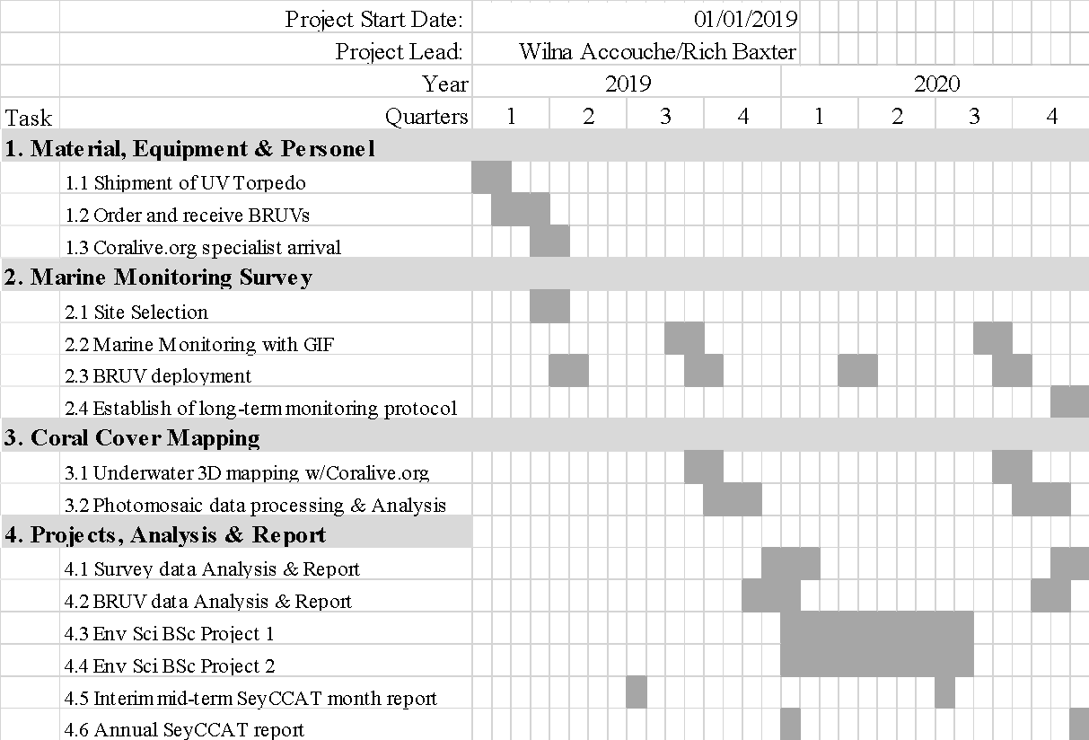
DO:
- Include infographics e.g GANTT charts if helpful and where relevant
- Be realistic in your scheduling

DON’T:
- Include activities that fall outside of the expected timeline of the project

Sustainability and replication
Indicate how the proposed activities are sustainable and may be scaled up or replicated. This can include an indication of follow-up activities, strategies, ownership, etc.
Also indicate what might go wrong / what are the possible obstacles or challenges to your proposed project?
The activities to achieve our stated objectives are designed to be continued after the two year budgeted project period. The establishment of a marine monitoring protocol into the overall conservation management plan of Frégate Island will ensure consecutive annual marine monitoring takes place in the future. Through this long-term monitoring, we will be able to monitor and analyse trends in the data, indicating where and when changes occur.
We will use multiple indicators to reveal system state changes including fish abundance, coral bleaching/recovery, and environmental variables (sea temperature and pH). As the methods are standardised through Green Islands Foundation that operate on other islands, there is great potential to compare the coral reefs between granitic islands of the Seychelles. Frégate Island has no chemical or oil run-off, sewage discharge, or over coastal development, therefore project results have potential for acting as a control for areas that suffer from known land-based threats to coral reefs in the Seychelles.
Challenges associated with a project of this size are often varied; for example, weather conditions dictate the timings on-water activities, training specific staff for activities can also overrun, and logistics to obtain equipment and personnel also present opportunities for project delays, but can be circumvented by organizing logistics ahead of the project start date. Publishing peer review papers can be a very time consuming exercise, therefore, achieving this output might only be achievable after project end. However, we endeavor to have submitted the paper to a journal by the project end.
DO:
- Indicate any possible challenges or obstacles to your proposed project
- Provide thorough indication of any follow-up activities and/or strategies

FINANCIAL INFORMATION

ANNEXES

ANNEXES

ANNEXES

ANNEXES

ANNEXES

ANNEXES

ANNEXES

Itemized Budget  (please also submit using the separate excel spreadsheet, and ensure the same line items are used as presented here).  IMPORTANT: Please ensure you consider costs associated with monitoring and evaluation, as well as any relevant taxes e.g if importing goods or paying overseas employees. | Refer to your proposed objectives and activities and include the cost:
 | Category | Year 1 | Year 2 (large grants only)
 | 1. Lead applicant salaries (inc. benefits) | 123456 SR | 123456 SR
 | 2. Communications | 123456 SR | 123456 SR
 | 3. Travel | 123456 SR | 123456 SR
 | 4. Supplies | 123456 SR | 123456 SR
 | 5. Equipment | 123456 SR | 123456 SR
 | 6. Contractual (sub-grant/s to partners) | 123456 SR | 123456 SR
 | 7. Training/Seminars/Workshops | 123456 SR | 123456 SR
 | 8. Other (specify) | 123456 SR | 123456 SR
 | 9. Management fee (if any) – may not be more than 10% of SeyCCAT request | 123456 SR | 123456 SR
 | TOTAL FUNDS REQUESTED OF SEYCCAT - PER ANNUM  TOTAL PROJECT COST – PER ANUM | 123456 SR  123456 SR | 123456 SR  123456 SR
 | TOTAL SEYCCAT FUNDS REQUESTED  TOTAL PROJECT COSTS | 123456 SR  123456 SR
DO:
- Make sure to include hidden costs, including those associated with monitoring and evaluation as well as relevant taxes
- Remember that the management fee cannot be more than 10% of the entire grant
- Make sure that the funding specified for each section is accurate and realistic – once an application has been approved, SeyCCAT are not able to allocate more funding

ANNEXES

ANNEXES

ANNEXES

ANNEXES

ANNEXES

ANNEXES

ANNEXES

ANNEXES

Please also submit a separate document that provides a summary of your project teams’ experience. It should include an annotated list of similar projects implemented and CV’s for the main project team members.
The application must not exceed five (5) pages, not including the budget, checklist and Annex.
DO:
- Make sure to include any and all information that supports your application or that is referred to in the main text of your Concept Note
- Accurately title each Annex and include information on its relevance to your project and the information provided in this Concept Note

CONCEPT NOTE CHECKLIST FOR SUBMISSION

ACTION | COMPLETE
Have you read the SeyCCAT Application Guidelines?
Have you read the environmental and social safeguards policy?
Have you referred to the glossary for explanations of different terms used in the proposal application form?
Have you used the correct Template for Concept Note Applications?
Have you checked the deadline time and date for the submission of the project?
Have you indicated the correct SeyCCAT strategic objective for this call?
Have you included CV’s for all the key project personnel?
Have you provided actual start and end dates for your project (and checked they synchronize with when SeyCCAT would make grant monies available)?
Have you checked the Guidelines on Generic Impacts and Risks of Activities to assess if an Environmental Impact Assessment needs to be carried out or supplemental environmental safeguards instruments prepared?
Have you provided your budget and used the correct template provided for concept notes?
Have you checked that your budget is complete, correctly adds up and that you have included the correct final total on the top page of the application?
If you are supported by co-finance - have you included the value of, and supporting organization for the co-finance, and indicated if it is cash or in kind?
Have you checked the SeyCCAT website immediately prior to submission to ensure there are no late updates?

Once you have answered Yes to the questions above, please submit the application in Word format, not later than 5PM (Seychelles time) on to the due date advertised in the request for proposals to:
info@seyccat.org using the title of the project (or first few words) as the subject of your email. You do not need to send a hard copy. Please note, you can submit any time before the due date, you do not have to submit on that date itself.
If you are e-mailing supporting documentation separately please include in the subject line an indication of the number of e-mails you are sending (e.g. whether the e-mail is 1 of 2, 2 of 3 etc). You are not required to send a hard copy.

